**Implementation of DHCP :**

Router#en

Router#config t

Enter configuration commands, one per line. End with CNTL/Z.

Router(config)#int fa 0/0

Router(config-if)# ip add 192.168.1.1 255.255.255.0

Router(config-if)#no shutdown

Router(config-if)#

%LINK-5-CHANGED: Interface FastEthernet0/0, changed state to up

%LINEPROTO-5-UPDOWN: Line protocol on Interface FastEthernet0/0, changed state to up

Router(config-if)#ex

Router(config)#ip dhcp pool cse

Router(dhcp-config)#network 192.168.1.0 255.255.255.0

Router(dhcp-config)#default-router 192.168.1.1

Router(dhcp-config)#dns-server 8.8.8.8

Router(dhcp-config)#ex

Router(config)#write memory%DHCPD-4-PING_CONFLICT: DHCP address conflict: server pinged 192.168.1.1.

Router#

%SYS-5-CONFIG_I: Configured from console by console

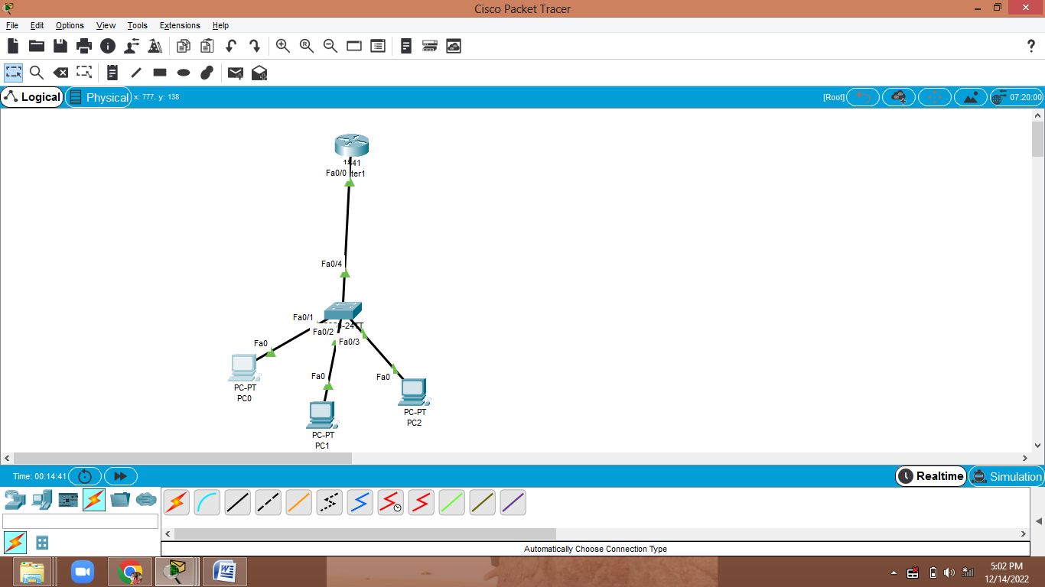

IMPLEMENTATION OF DHCP WITH ONE DNS AND ONE WEB SERVER

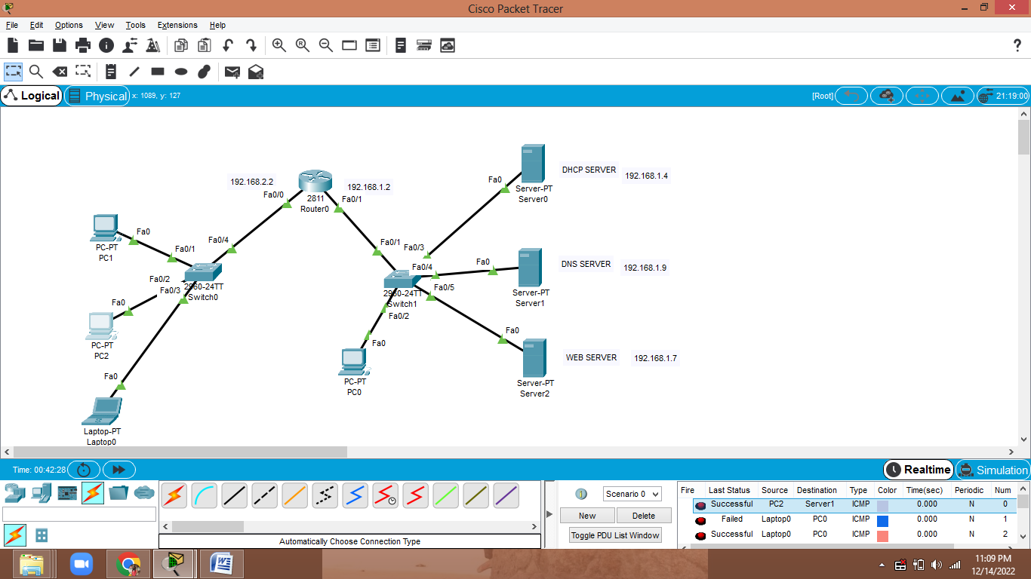

Router 0

Dhcp configuration:

Router(config-if)#ip dhcp pool p1

Router(dhcp-config)#network 192.168.1.0 255.255.255.0

Router(dhcp-config)#default-router 192.168.1.2

Router(dhcp-config)#ex

Router(config)#ip dhcp pool p2

Router(dhcp-config)#network 192.168.2.0 255.255.255.0

Router(dhcp-config)#default-router 192.168.2.2

Router(dhcp-config)#ex

Router(config)#

